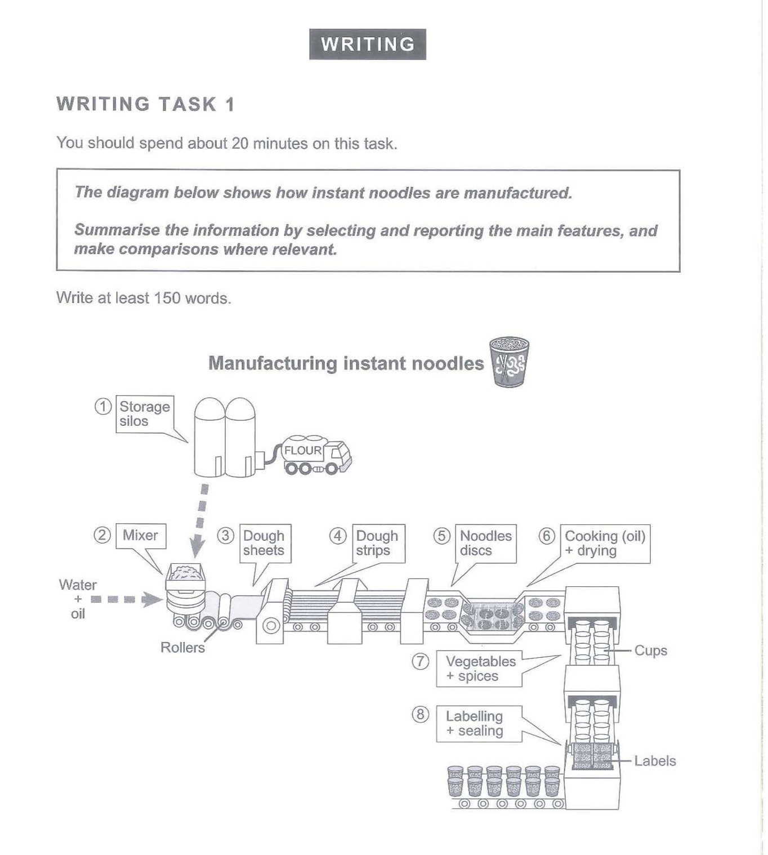
The picture illustrates the process of producing instant noodles. Overall, the whole process is complex, which can be divided into five critical stages: storing flour, making dough, shaping noodles, cooking discs and labelling cups.

First of all, flour is derived by trucks and stored in storage silos. Then, it is transferred to a mixer to be mixed with water and oil. In the following step, the mixture is turned into dough sheets by rollers, which are later cut into strips. In the next stage, the stripes are shaped into noodle discs through moulds.

After this, the noodle discs go through two essential procedures: they are firstly cooked with oil and then dried before they are put into cups together with vegetables and spices. When all ingredients are in the cups, labelling and sealing start. Finally, the sealed and labelled cups are transported to somewhere, and the entire manufacturing is completed.

(~150 words)

